Trainer’s Guide:
Leading Focused Conversations with
Families to Help Complete the DRDP (2015)
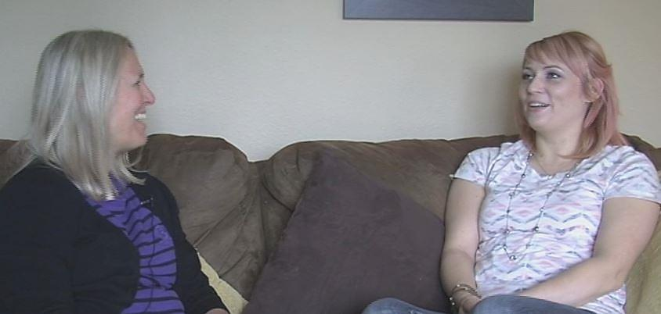
B

By Larry Edelman with Sharon Botkin and Patty Salcedo

© 2016 Desired Results Access Project, Napa County Office of Education.
Funded by the California Department of Education (CDE), Special Education Division
This publication was produced by the Desired Results Access Project to support the implementation of the DRDP (2015) for the Special Education Division of the California Department of Education.
Permission is granted to reproduce the document in its entirety for the purpose of professional development.
Suggested Citation:
Edelman, L., Botkin, S, & Salcedo, P. (2019). Trainer’s Guide: Leading Focused Conversations with Families to Help Complete the DRDP (2015) – Version 2. Petaluma, CA: Desired Results Access Project, Napa County Office of Education
For information contact:
Web site: www.draccess.org
E-mail: info@draccess.org
Phone: (800) 673-9220

Contents
Introduction 4
Preparing to Lead the Workshop 5
Materials and Equipment Needed 6
Trainer’s Notes 7

Introduction
Over the past few years the Desired Results Access Project has been developing a process that home visitors can use so they can more confidently complete the DRDP (2015), even when they may not have had frequent opportunities to observe the child participating in a variety of routines and activities. Two important aspects of this process are:
- Having focused conversations with families.
The ongoing conversations that we have with family members during our typical interactions with them are rich opportunities for learning about their child. Notes of what the family shares during these conversations should be captured and included as documentation in the child’s portfolio, home visiting notes, or other system of organizing information about the child. These kinds of general conversations should occur whenever we have contact with the family. Additionally, it may be useful to lead conversations in a particularly focused manner during the two times a year when the DRDP (2015) is completed. Having conversations with families is an important part of completing the DRDP (2015) for all assessors, but it may be particularly important for practitioners such as home visitors who may not have frequent opportunities to observe the child participating in a variety of routines and activities. When combined with your observations, the perspectives of families help you gain a more complete picture of a child across settings, activities, and interacting with a variety of people.
- Focusing on the child and family’s typical routines and activities.
Leading a focused conversation with a family is particularly important to obtain information on measures that you have not had the opportunity to observe. During these conversations, focusing on routines and activities provides a very useful context for asking a family about their child’s everyday learning opportunities and skills.
The purpose of this workshop is for home visitors to understand and be able to start using this process. This workshop supplements “Using the DRDP (2015) for Special Education,” a training program for all practitioners who use the DRDP (2015). Although this session is designed specifically for home visitors, other practitioners may find it useful as well.
Thanks to those who helped develop this conversational process: Larry Edelman, Sharon Botkin, Patty Salcedo, Pat Snyder, Mary McLean, and Anne Kuschner and reviewers Donna Sullivan and Dillon Henry. Special thanks to Sharon Botkin and Lindsey and her family for their partnership in producing the video illustration of the process.

Preparing to Lead the Session
Following are recommended activities for trainers to complete to develop the expertise required to lead this session.
Attend a TTT workshop
- If at all possible, attend a Train-the-Trainer workshop for learning to use the DRDP (2015) presented by the Desired Results Access Project.
Get to Know the DRDP (2015)
- Become very knowledgeable regarding the DRDP (2015).
- Become familiar with www.draccess.org and the resources to be found at this site.
- Practice using the DRDP (2015) with at least one child before leading the workshop.
Get to Know the Workshop Material
    - Read the handout “Leading Focused Conversations with Families to Help Complete the DRDP (2015).”
    - Review the “Worksheet for Leading Conversations with Families to Help Complete the DRDP (2015).”
    - Following along with the handout and worksheet, watch the video “Leading Focused Conversations with Families to Help Complete the DRDP (2015): Focusing on Everyday Routines and Activities.”
    - Carefully read through the Trainer’s Notes and the handout materials so you can lead each discussion in a relaxed manner and know what to say. Please remember – make the points outlined in the Trainer’s Notes genuinely in your own words; these points should not be memorized or read.
    - Practice using this process with at least one family before leading the workshop.
Practice Using the Audio-Visual Materials and Equipment
    - Learn how to use the audio-visual equipment. Practice setting up and using your laptop computer with a projector and speakers. Practice toggling back and forth between using PPT slides and the video clips. Practice showing the video clips and adjusting the volume of them.
Plan How to Work Together with your Co-Trainer Effectively
- It is sometimes useful to have a team of two trainers present the workshop. Meet with your co-trainer and support staff in advance to plan: who will lead which activities; how you can support each other; ways to ensure the activities will be delivered accurately; and, for all the logistical arrangements that need to be made.

Materials and Equipment Needed
Trainer’s Materials
- Trainer’s Guide: Trainer’s Guide: Leading Focused Conversations with Families to Help Complete the DRDP (2015)
- Video: Leading Focused Conversations with Families to Help Complete the DRDP (2015): Focusing on Everyday Routines and Activities https://www.draccess.org/videolibrary/LeadingConversations
- Video: Crystal Moving Around https://www.draccess.org/videolibrary/CrystalMovingAround
- PowerPoint Slides: Guidance for Home Visitors: Leading Focused Conversations
with Families to Help Complete the DRDP (2015)
Materials for Participants
- Document: Leading Focused Conversations with Families to Help Complete the DRDP (2015)
- Worksheet for Leading Conversations with Families to Help Complete the DRDP (2015)
- Optional Thumbnails of PowerPoint Slides
- Evaluation Form
Equipment
- Laptop computer with:
    - Free software for playing the videos. On both PCs and Macs we recommend you use VLC Media Player (http://www.videolan.org) or UMPlayer (https://sourceforge.net/projects/umplayer/). Additionally, on Macs, you might also use QuickTime Player (www.apple.com) however QuickTime for Windows is NOT recommended for PCs. If you have QuickTime for Windows installed on a PC, the United States Computer Emergency Readiness Team recommends that you uninstall it (https://www.us-cert.gov/ncas/alerts/TA16-105A).
    - Recent versions of Microsoft PowerPoint and Word.
    - The most recent version of the free Adobe Reader, available at http://get.adobe.com/reader
- LCD projector
- Projection screen
- Audio speakers to amplify the sound from the laptop
- Tables for the laptop and projector
- Surge protector(s)/power strips
- Extension cord(s)
- Cable to connect the computer to LCD (important: this usually requires a longer than standard cable)
- Cables to connect the computer to the audio system (important; this often requires a longer than standard cable)
- Easel, colored markers, chart paper, and masking tape and/or push pins for affixing chart paper to the wall

Trainer’s Notes
This session might take from 2 to 2.5 hours to present, depending on the length of discussions.
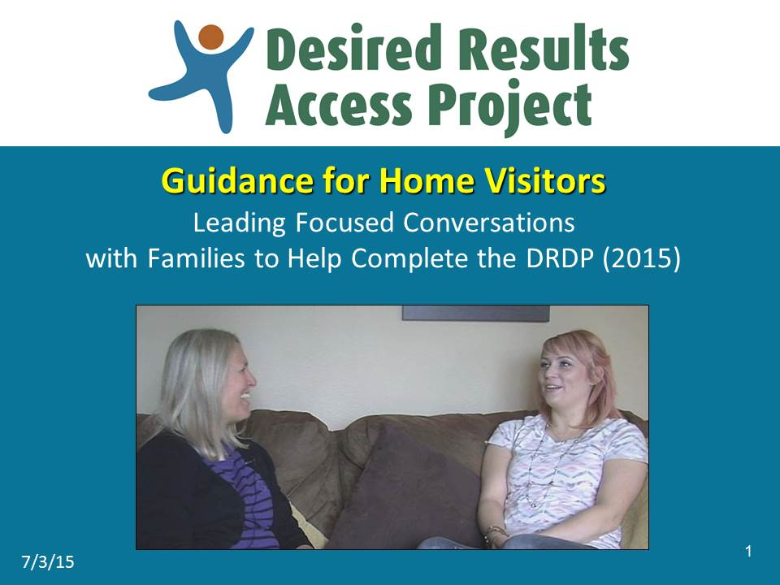 | Slide 1. Show the title slide and make these points:  - Welcome everyone.
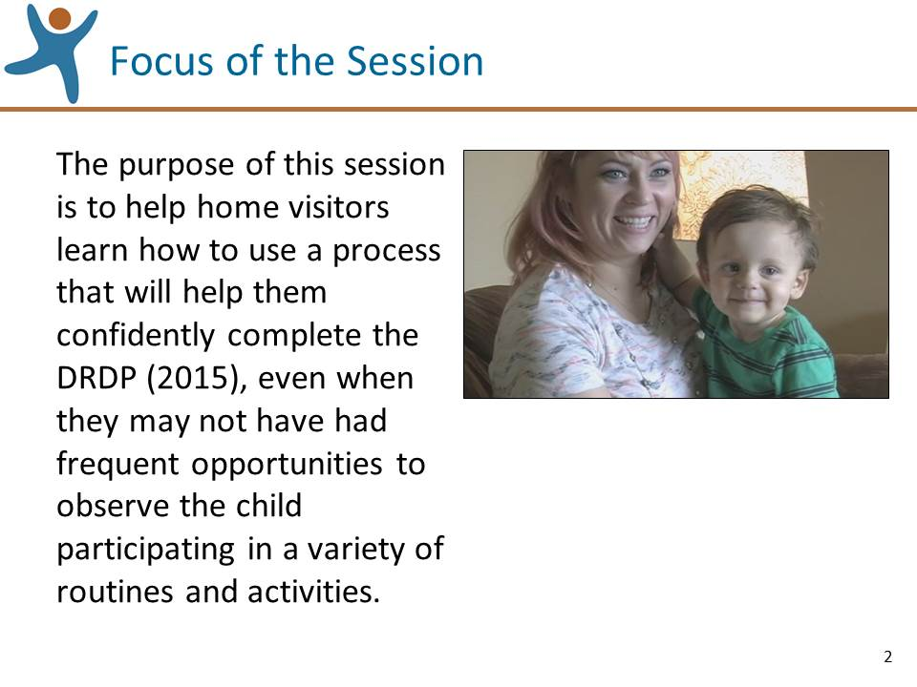 | Slide 2. Review the information on this slide and make these points:  - Over the years the Desired Results Access Project has been developing a process that home visitors can use to confidently complete the DRDP, even when they may not have had frequent opportunities to observe the child participating in a variety of routines and activities.  - The purpose of this session is to share this process and some useful tools that you can use along with it.
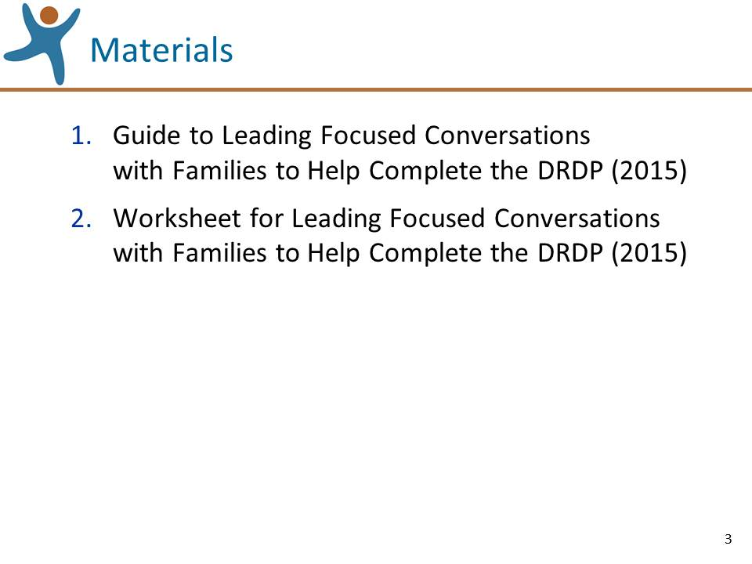 | Slide 3. Review the information on this slide and make these points:  - The Guide describes in detail the process that we will be reviewing. All of the information we will discussing is included in this handout.  - The Worksheet is a tool that is used during the process.
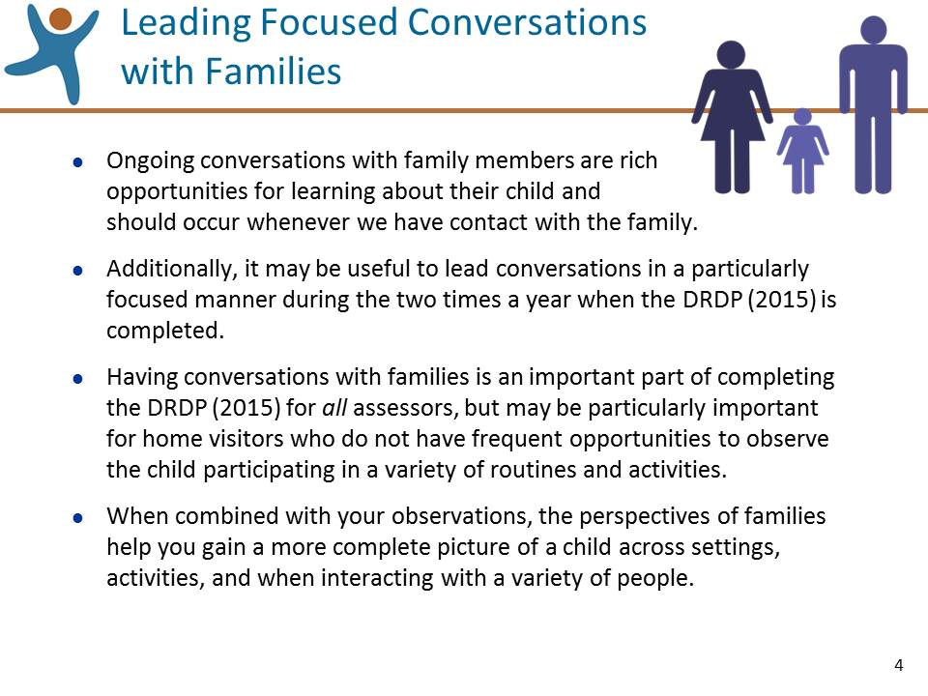 | Slide 4. Review the information on this slide and make these points:  - Although this process was designed specifically for early intervention home visitors, all teachers and service providers who complete the DRDP (2015) may find it useful.
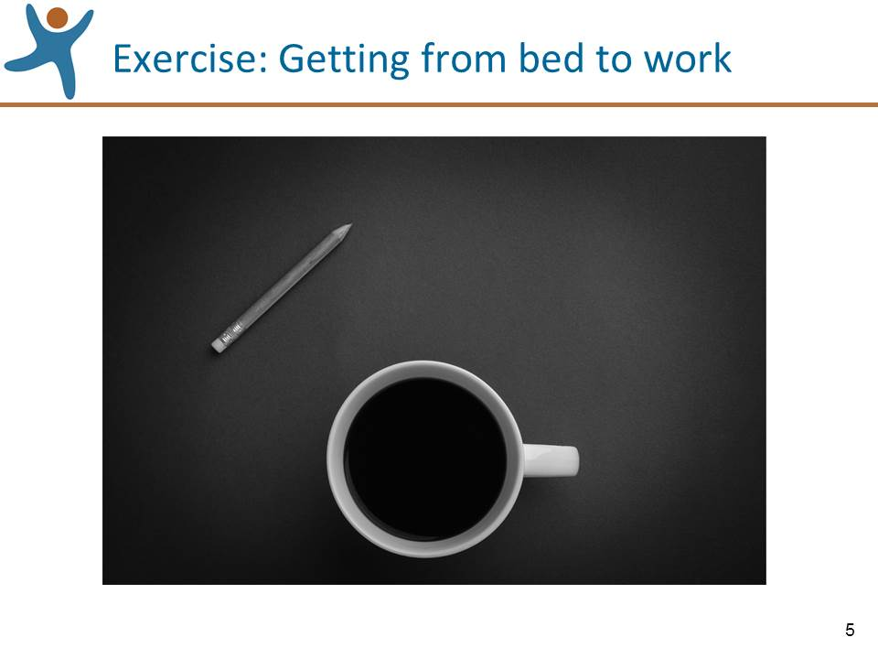 | Slide 5. Show this slide and lead this activity:  - The process that we will review today is based on having a conversation around routines, so let’s try a fun exercise to get a feel for talking about routines.  - Find one partner (just one partner!).  - Decide who will be the interviewer and who will be the interviewee.  - After the partners decide on their roles, give the interviewers the task: Ask respectful questions and demonstrate active listening so that you will have a good understanding of your partner’s typical routines in the morning from the moment they open their eyes until they arrive at work.  - Remind the interviewees to only share what they feel comfortable sharing.  - Tell them they have 5 minutes for this conversation.  - After five minutes debrief the activity by asking both the interviewers and the interviewees to share their reflections, thoughts, or feelings having completed this activity. If you think prompts are necessary:  - For the interviewers: How difficult was it to maintain open-ended questions?  - For the interviewees: How comfortable did you feel answering the questions asked of you? What would have helped you feel comfortable?  - Summarize this activity:  - We can learn so much by asking open-ended questions and listening actively and attentively.  - We can demonstrate our active listening and engagement through our eye contact, posture, and gestures.
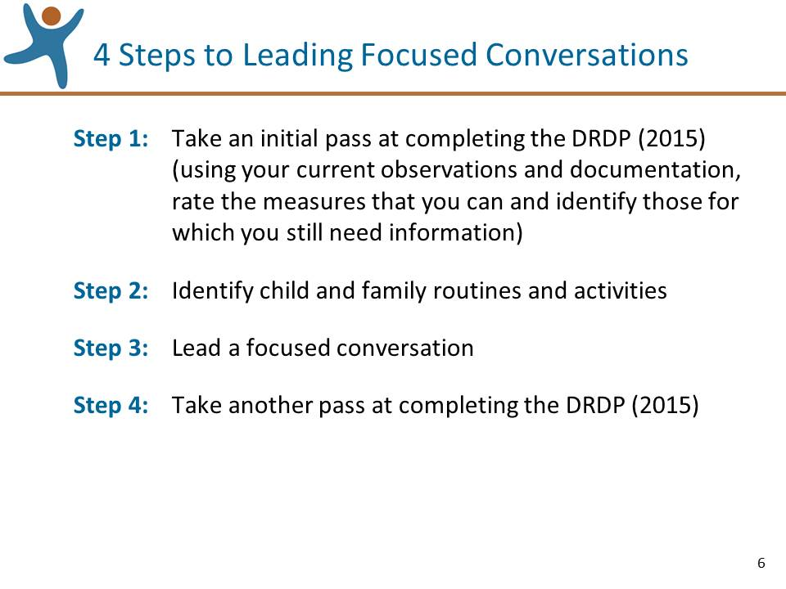 | Slide 6. Review the information on this slide and make these points:  - The process we’ll be reviewing uses the 4 steps on this slide for leading focused conversations.  - We’ll review these steps by watching video illustrations.
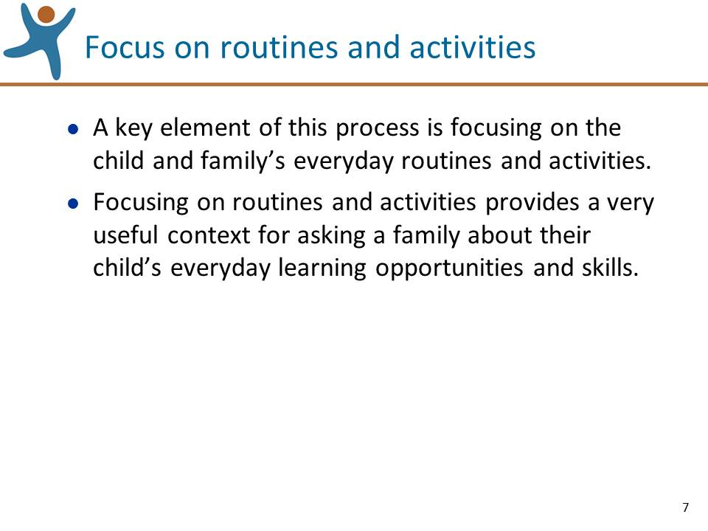 | Slide 7. Review the information on this slide and make these points:  - For example, if you have not had the opportunity to directly observe the child interacting with peers (SED4: Relationships and Social Interactions with Peers), the family can share observations of their child spending time with other children (e.g., at play dates, birthday parties, at the playground).
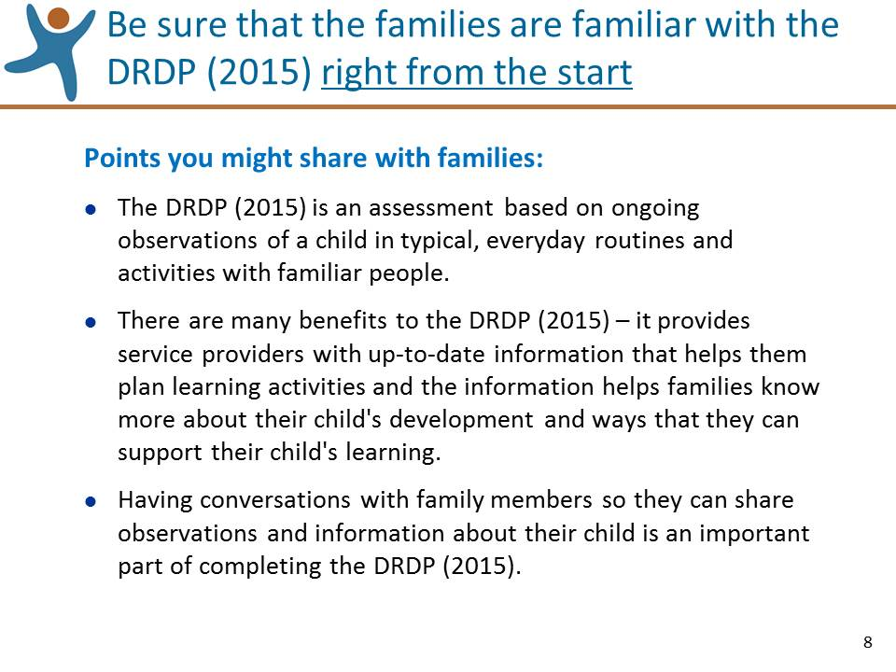 | Slide 8. Review the information on this slide and make these points:  - Be sure that the families that you work with are familiar with the DRDP (2015) right from the start. Consider sharing the document, ““An Overview of the DRDP (2015) for Families” that can be found at: http://www.draccess.org/families  - Don’t wait until the time periods when the DRDP (2015) data is due! Early in the service delivery relationship, let the families know that you will be completing the DRDP (2015) two times a year and talk with them about how they can participate in the process.  - On this slide are some points you might share with families.
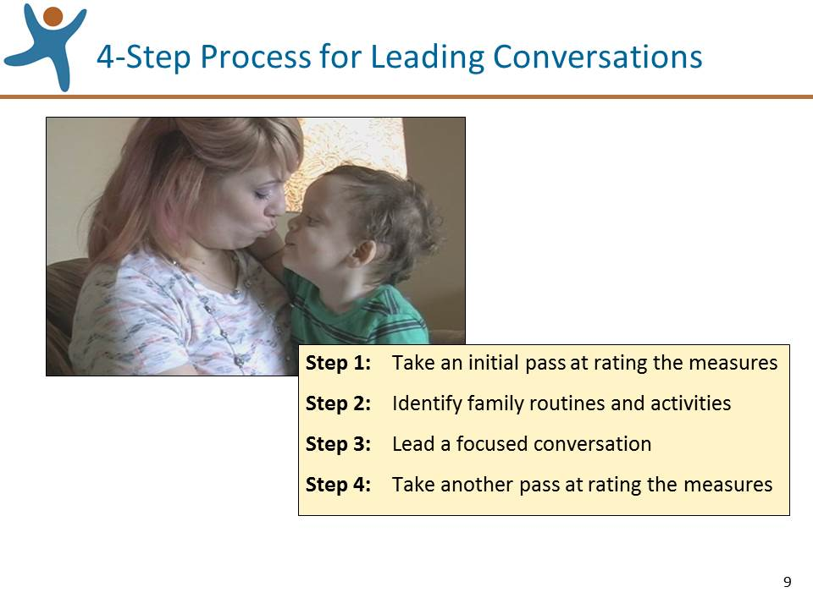 | Slide 9. Review the information on this slide and make these points:  - For the rest of the session, we’ll review these four steps by watching a video in which Sharon Botkin, an Early Childhood Special Education Teacher with the Sacramento County Office of Education, describes and illustrates the process.  - We appreciate Sharon’s willingness to demonstrate this process and also to the parent in the video, Lindsey, for her key role in illustrating the process.  - Please keep a couple of things in mind:  - We asked Sharon to “think aloud” during her assessment so we can illustrate the steps of the rating process.  - The video we’ll watch does not include the entire process, but has been edited to show selected segments of the process, just enough to illustrate the four steps.  - It is important to remember that when completing the first DRDP (2015) assessment with a child, be sure that you have spent enough time getting to know the child by observing the child’s skills during typical routines/activities and by having ongoing conversations with the family.
Show the  opening section  (0:00 – 1:13) | SHOW VIDEO  - The section of the video we are about to watch is of Sharon Botkin describing the four steps that will be illustrated in the video.  - Show the opening section of the video from the beginning until 1:13.  - Pause the video at 1:13, just after Sharon says “…confidently rate the measures.”  - When this section of the clip ends ask if there are any GENERAL questions about the four steps of the process and answer them. If questions are asked that will be addressed in upcoming sections of the session, acknowledge that the question will be addressed shortly.
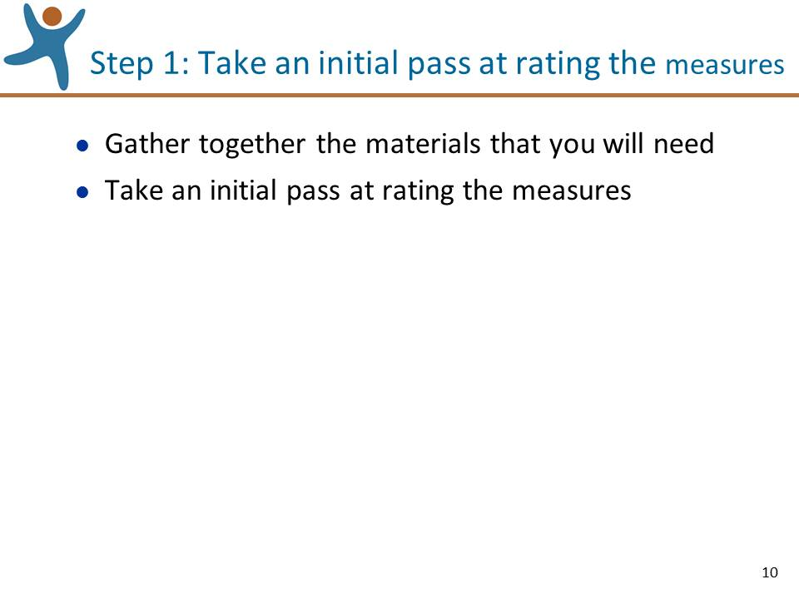 | Slide 10. Review the information on this slide and make these points:  - The first step has these two parts. Let’s review them one at a time.
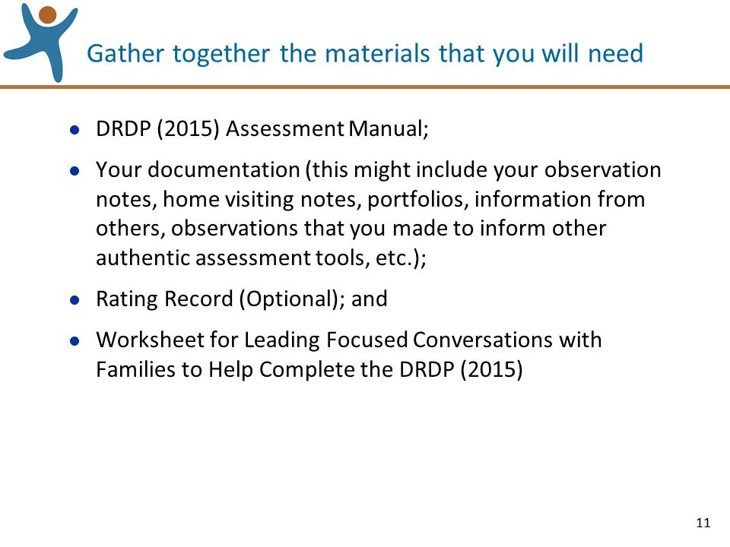 | Slide 11. Review the information on this slide and make these points:  - DRDP (2015) Assessment Manual: you’ll need this when you rate the measures  - Your documentation might include any or all of the sources of information on this slide.  - Ultimately, you’ll need to record your ratings directly on the Rating Record, so it might be efficient to have one handy so that when you are confident in rating a measure, you can indicate the score right on the Rating Record, instead of having to copy it over at a later date.  - Let’s take a closer look at the Worksheet on the following slide.
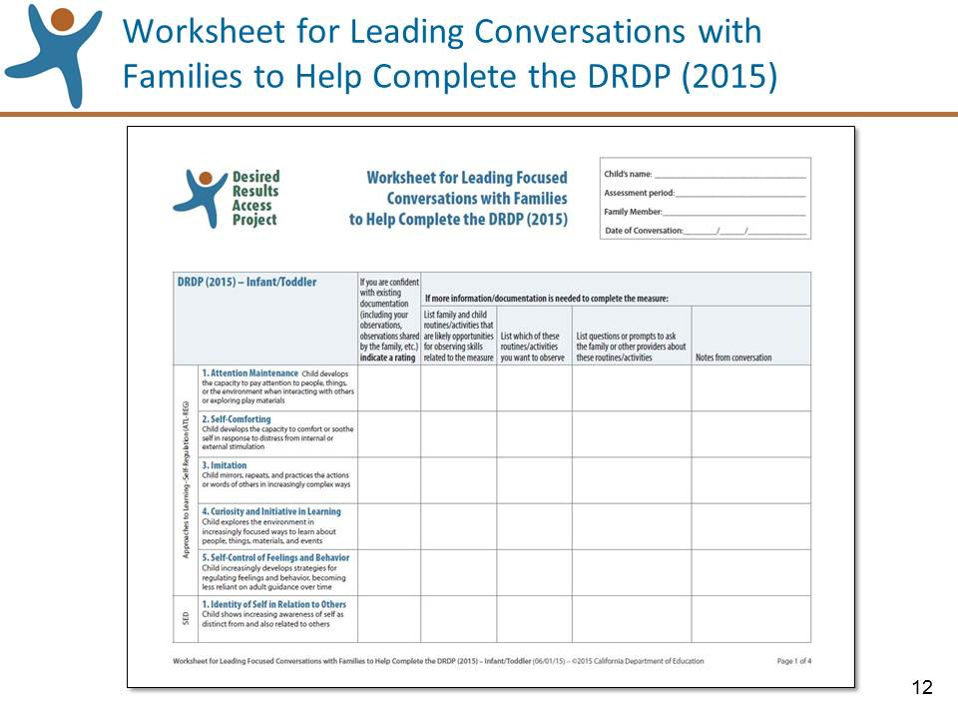 | Slide 12: Review the information on this slide and make these points:  - The Worksheet can help you keep track of which measures you can and cannot rate and plan for future observations and conversations.  - On this slide is the Worksheet formatted for the IT view of the DRDP (2015). There also is a version for the PS view. Other than the number of measures that appear, the two versions of the worksheet are identical.  - Let’s walk through the headings and talk briefly about how they are used.
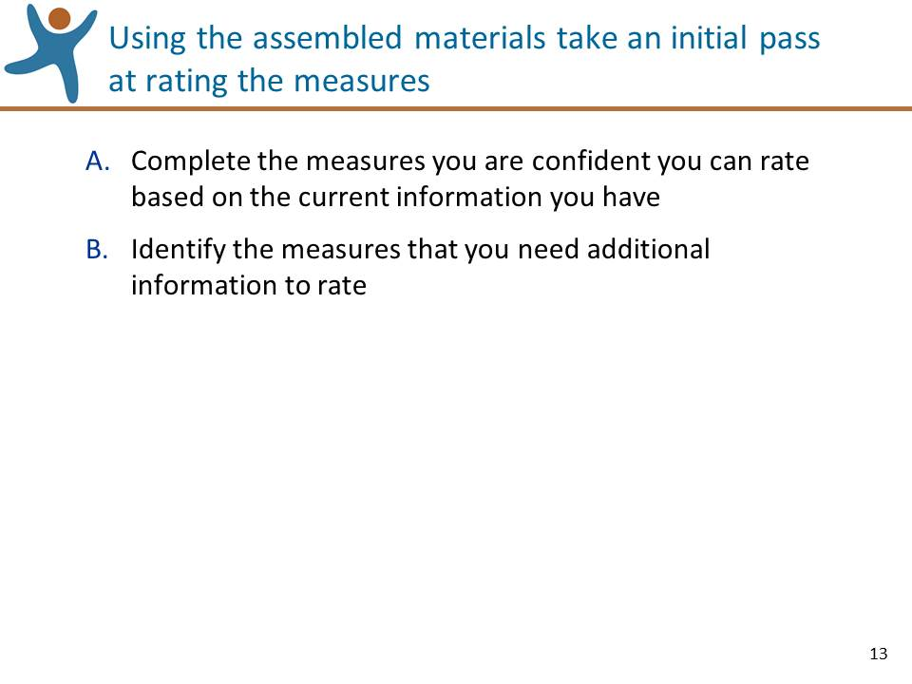 | Slide 13: Review the information on this slide and make these points:  - When taking your initial pass at completing the instrument it is likely that you’ll encounter measures you are confident you can rate based on your information as well as other measures that you feel you need additional information/documentation to rate confidently.
Show the first  section of Step 1:  Gathering Materials  (1:13 – 2:23) | SHOW VIDEO  - The next section of the video we are going to watch is of Sharon describing the materials that she gathered together.  - Show the first section of Step 1 on Gathering Materials (1:13 until 2:23).  - Pause the video at 2:23, just after Sharon says “…or if it’s just emerging.”  - Lead a discussion: Ask the participants what additional materials they might gather.  - Ask if there are any questions about gathering materials and answer them. If questions are asked that will be addressed in upcoming sections of the session, acknowledge that the question will be addressed shortly.  - POINTS TO MAKE:  - It’s important to note that Sharon has been working with Westly for over a year. If you have just started working with a child, you should observe the child as much as you can before attempting to rate the instrument.  - In the video, Sharon is using an older version of the worksheet, formatted in portrait orientation. The worksheet is now formatted in a landscape orientation, allowing more room to write.
Show the second  section of Step 1:  Confidently Rating  PD-HLTH7  (2:23 – 4:56) | SHOW VIDEO  - The next section of the video we are going to watch is of Sharon being able to confidently rate a measure, PD-HLTH 7, using the information that she has at hand.  - Show the second section of Step 1 on Confidently Rating PD-HLTH7: Feeding with existing documentation (2:23 until 4:46).  - Pause the video at 4:56, just after Sharon says “emerging to building earlier.”  - When you arrive at a confident rating you might record it on the Worksheet or right on the Rating Record.  - Ask if there are any questions about confidently rating a measure using the information at hand. If questions are asked that will be addressed in upcoming sections of the session, acknowledge that the question will be addressed shortly.
Show the third  section of Step 1:  Needing More Info to Rate PD-HLTH 6 & PD-HLTH 8  (4:56 – 7:35) | SHOW VIDEO  - The next section of the video we are going to watch is of Sharon identifying that she needs more information to rate two measures, PD-HLTH 6: Hygiene and PD-HLTH 8: Dressing.  - Show the third section of Step 1 on needing more info to rate PD-HLTH 6: Hygiene & PD-HLTH 8: Dressing (4:56 until 7:35).  - Pause the video at 7:35, just after Sharon says “What does that look like?”  - Ask if there are any questions about identifying when you need more information to confidently rate a measure. If questions are asked that will be addressed in upcoming sections of the session, acknowledge that the question will be addressed shortly.
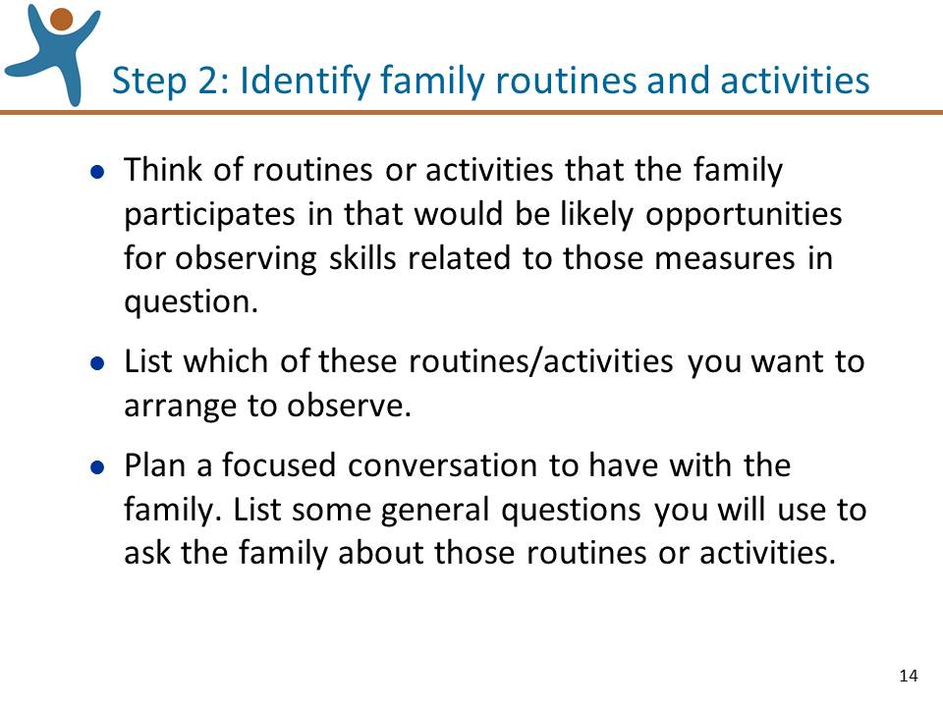 | Slide 14. Review the information on this slide and make these points:  - In step 1, Sharon rated some measures and also identified some measures for which she needed more information. Now in Step 2, she will use her knowledge about the child and family to think of routines or activities that they participate in that would be likely opportunities for observing skills related to those measures. For example, if information is needed about measures related to the Social and Emotional Development domain the focus might be on what happens when the child interacts with others at the park or playground, or when friends visit.  - Once you have these routines or activities in mind you can plan which of these you want to arrange to observe and which you want to talk about with the family. In some cases you might want to do both.  - When you plan a focused conversation with the family you can list some general questions you will use to ask about those routines or activities. For example, “Please tell me what [child’s name] does when friends come to visit who have a child around his age.”  - You can jot down these questions in the appropriate column on the Worksheet.
Show the  section on Step 2:  Identify Family Routines and Activities  (7:36 – 9:09) | SHOW VIDEO  - The next section of the video we are going to watch is of Sharon illustrating Step 2, identifying family routines and activities and planning which she wants to observe and which she wants to talk about with the family.  - Show the section on Step 2: Identify family routines and activities (7:36 – 9:09).  - Pause the video at 9:09, just after Sharon says “…want to make sure I capture all this.”  - Lead a discussion:  - What family routines and activities did Sharon identify to talk about with Lindsey, Wesley’s mother?  - What questions did Sharon come up with to ask Wesley’s mother?  - Ask if there are any questions about identifying family routines and activities and planning which to observe and talk about with the family. If questions are asked that will be addressed in upcoming sections of the session, acknowledge that the question will be addressed shortly.
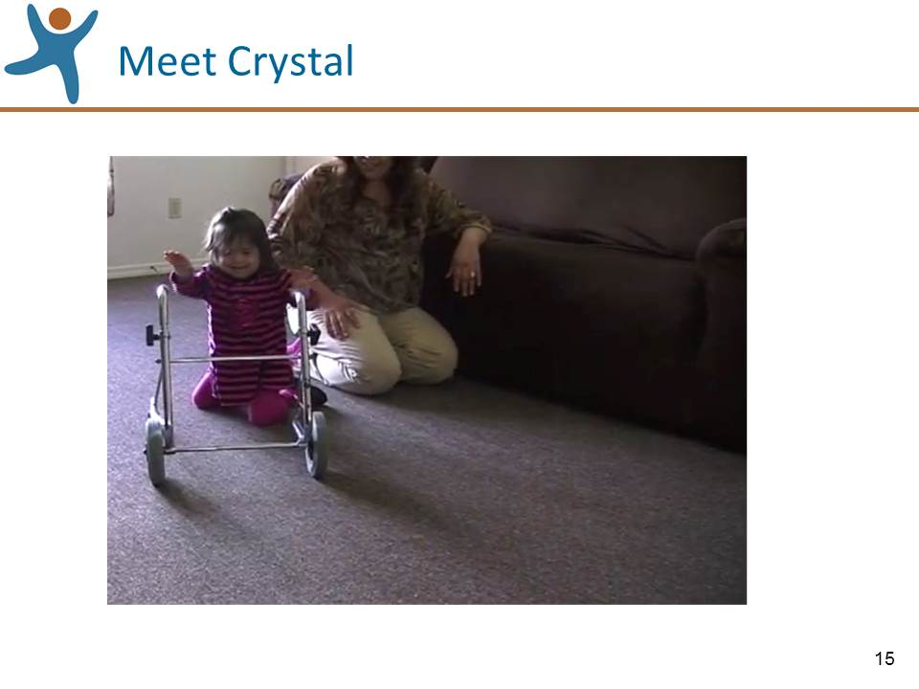 | Slide 15. Show this slide and make these points:  - Let’s do an exercise that will help us get a good feel for this step of the process, identifying family routines and activities, and questions that we might ask.
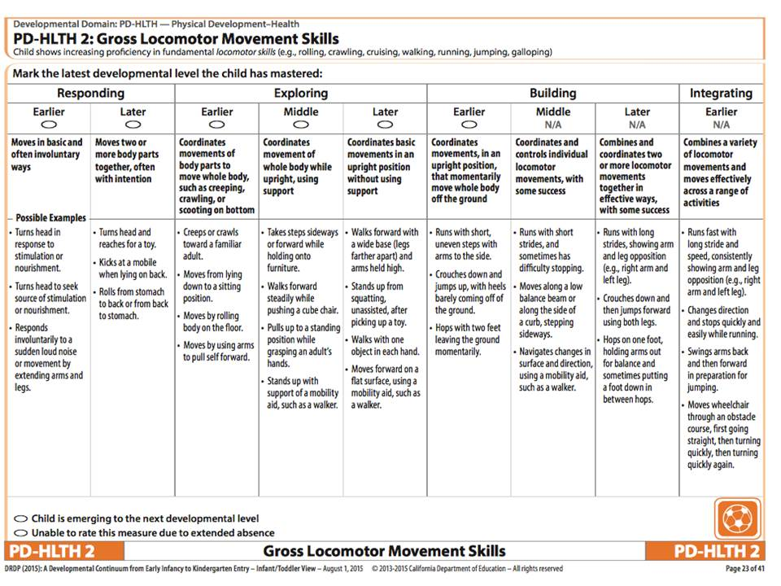 | Slide 16. Show this slide and make these points:  - Let’s review a measure on the DRDP (2015), PD-HLTH 2: Gross Locomotor Skills. (Walk the participants through the levels and a few examples.)
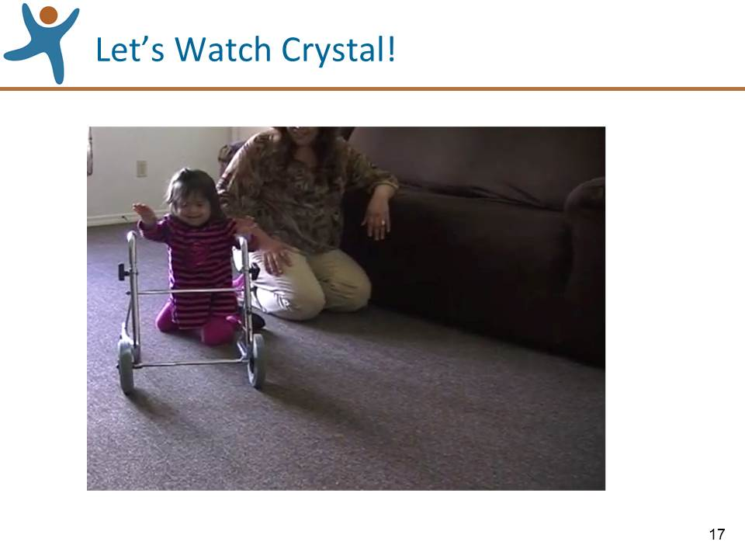 | Slide 17. Show this slide and make these points:  - We’re going to watch a short clip of a young girl named Crystal. As you watch, think about what we know and don’t know about Crystal’s skills related to PD-HLTH 2 from the information in the clip.  - Show the video clip of Crystal Moving Around.
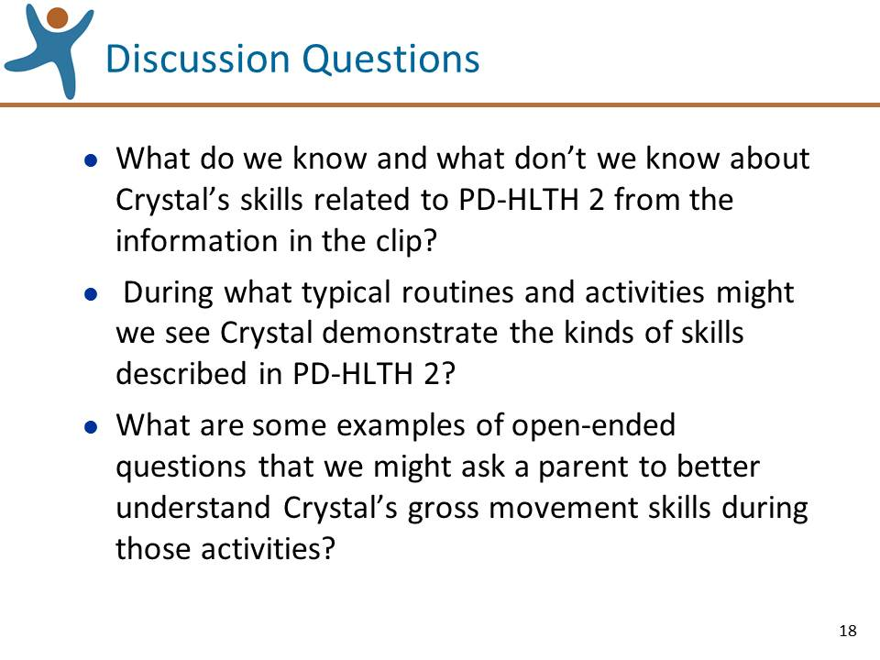 | Slide 18. Show this slide and lead a discussion:  - Lead a conversation in a large group by asking these three questions in order. NOTE: be sure to capture the routines and activities and the questions that are identified in questions 2 and 3 on chart paper or type them on a blank slide.  - What do we know and what don’t we know about Crystal’s skills related to PD-HLTH 2 from the information in the clip? (If needed, refer back to slide 16)  - During what typical routines and activities might we see Crystal demonstrate the kinds of skills described in PD-HLTH 2? (If you need to give an example or two: moving from place to place during playtime, moving to the kitchen for mealtime, climbing onto furniture for a quiet time story).  - What are some examples of open-ended questions that we might ask a parent to better understand Crystal’s gross movement skills during those activities? (If you need to give an example or two: How does Crystal get up in the morning? What does she do on her own? What do you do to assist her? Are there any special items/devices that help her move?; When it is time for breakfast, tell me how Crystal is involved. What does she do on her own? What supports do you give her? How does she get to the table? You mentioned you like to go to the park – how does Crystal get ready to go to the park? When you are at the park, describe the things that Crystal likes to do?  - Summarize the activity: It is important to be familiar with and reflect on the family’s typical routines and activities when identifying questions to ask.
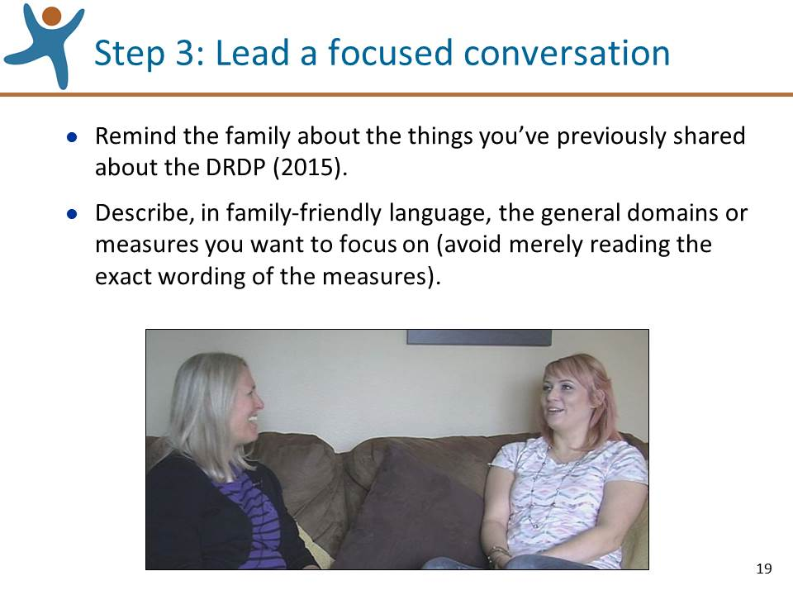 | Slide 19. Review the information on this slide and make these points:  - In Step 2, Sharon used her knowledge about the child and family, to think of routines or activities that they participate in that would be likely opportunities for observing skills related to those measures. Now, in step 3, she will lead the focused conversation with the family.  - Be sure to remind the family about the things you’ve previously shared about the DRDP (2015).  - Be sure to describe, in family-friendly language, the general domains or measures you want to focus on. For example, if you want to focus the conversation on measures within the Social and Emotional Development domain, you might say, “Let’s talk about how [child’s name] typically interacts with people.”
Show the  section on Step 3:  Lead a Focused Conversation  (9:10 – 16:41) | SHOW VIDEO  - The next section of the video we are going to watch is of Sharon illustrating Step 3, leading a focused conversation with the family.  - You’ll see that during the conversation, you can take notes on the Worksheet.  - Show the section on Step 3: leading a focused conversation (9:10 – 16:41).  - Pause the video at 16:41, just after Sharon says “That’s great, yeah, yeah.”  - Lead a discussion:  - What questions did Sharon use?  - In what ways were Sharon’s questions “family-friendly”?  - What follow-up questions did Sharon use?  - What did Sharon learn from her conversation with Wesley’s mother?  - We only watched Sharon lead a conversation to get information about a couple of measures. In practice, you would repeat these kinds of conversations with other routines or activities you have identified until you have enough information to confidently rate the measures in question.  - One additional idea is to lead a conversation while you and the family watch a video together of the child participating in a routine or activity (the video might be taken by either you or the family). You and the family can share what you each observe and talk about whether this video clip is consistent with what the family sees at other times.  - Ask if there are any questions about leading a focused conversation with the family. If questions are asked that will be addressed in upcoming sections of the session, acknowledge that the question will be addressed shortly.
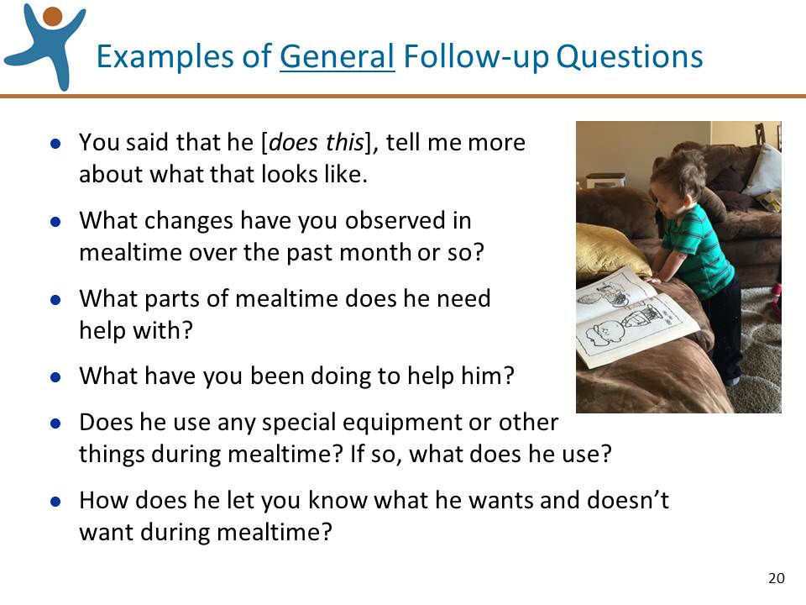 | Slide 20. Review the information on this slide and make these points:  - After the family member answers your questions, you might ask some follow-up questions.  - The examples of general follow-up questions on this slide are included in your handout.
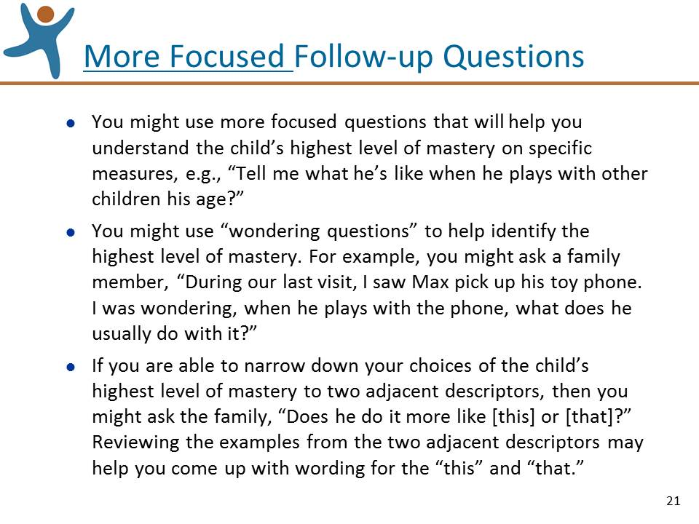 | Slide 21. Review the information on this slide and make these points:  - Also in your handout is a list of more focused follow-up questions.  - The third bullet on this slide describes a strategy you might use when you are able to narrow down the child’s mastery to two adjacent levels. For example, if we were looking at PD-HLTH 2: Gross Locomotor Movement Skills, if you’re thinking that the child’s highest level of mastery is either Responding Earlier or Responding Later, based on your review of the examples from these two descriptors you might ask, “When [child’s name] sees something interesting, does he look at it and does he also reach for it?”
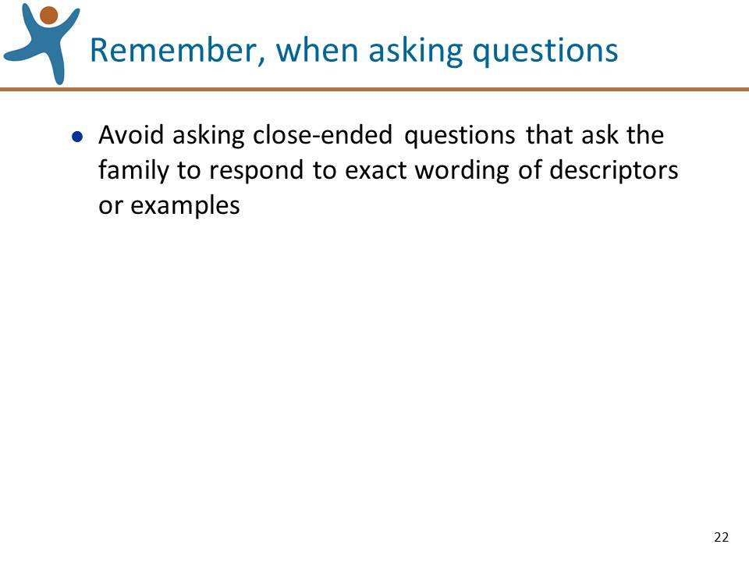 | Slide 22. Review the information on this slide and make these points:  - An important caution is to avoid asking close-ended questions that ask the family to respond to the exact wording of descriptors or examples. For example for ATL-REG 4: Self-Control of Feelings and Behaviors, avoid asking questions that simply repeat a descriptor verbatim, such as “When [child’s name] is upset, does he seek out an adult for comfort or does he calm himself?” Rather, ask more open-ended questions, such as, “All children get upset from time to time – what happens when [child’s name] gets upset over something?”
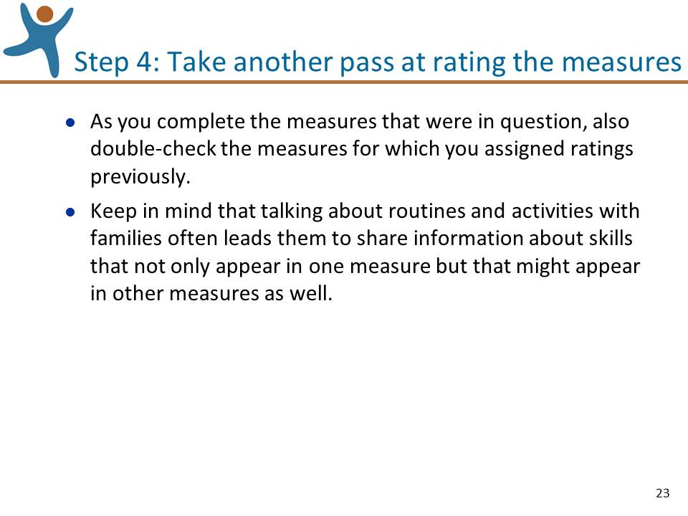 | Slide 23. Review the information on this slide and make these points:  - In Step 3, Sharon led the focused conversation with the family. Now, in Step 4, with the information she learned from Westly’s mother, she’ll take another pass at rating the measures that were in question.  - We can imagine an example of the points on this slide in regard to Wesley and mealtime. When asking Wesley’s parents what he does during mealtime, the family might describe what Wesley does related to feeding, but also how he interacts with others, thus sharing important information that could inform the rating of other measures.
Show the  section on Step 4:  Take Another Pass at Rating the Measures  (16:42 – 19:36) | SHOW VIDEO  - The last section of the video we are going to watch is of Sharon taking another pass at rating the measures that were in question.  - Show the section on Step 4: Take another pass at rating the measures that were in question (16:42 – 19:36).  - Pause the video at 19:36, just after Sharon says, “…emerging to that next level.”  - If there are still measures that you still cannot confidently rate, repeat the steps until you can confidently rate all of the measures on the DRDP (2015).

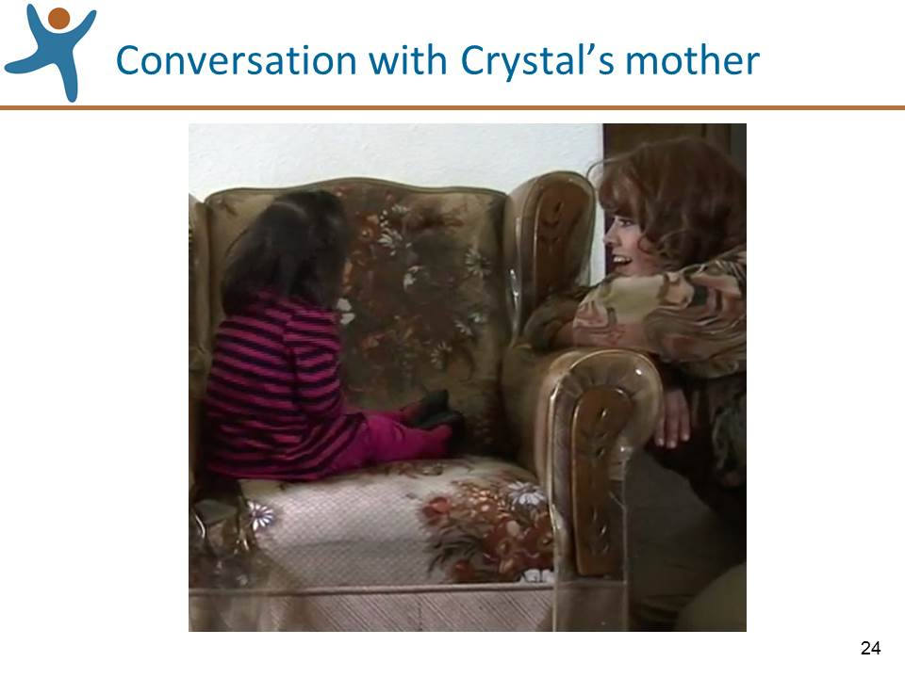 | Slide 24. OPTIONAL ACTIVITY IF TIME PERMITS: Show this slide and lead this activity:  - Let’s try an exercise to get a feel for leading conversations  - Find one partner (just one partner!).  - Decide who will be the interviewer and who will play the role of Crystal’s parent.  - After the partners decide on their roles, review with the group the list of routines and questions that they identified during the earlier activity.  - Give the interviewers the task:  - The interviewers should use the practices that we reviewed in this session to ask questions and demonstrate active listening to “fill in the blanks” on what we still don’t know about Crystal’s skills related to PD-HLTH 2 so that they could feel confident in assigning a tentative rating to the measure.  - The person playing the parent should make up answers that they feel are indicative of Crystal’s level of development in this area.  - Tell them they have about 5 minutes for this conversation.  - After about five minutes debrief the activity by asking both the interviewers and the interviewees to share their reflections, thoughts, or feelings having completed this activity. If you think prompts are necessary:  - For the interviewers: were you able to gather useful information from the answers you received?  - For the interviewees: As Crystal’s parent, were the questions clear and were you comfortable answering?  - Summarize this activity:  - Keep in mind that parent observations are valuable, reliable and a key part of assessment documentation.  - During these kinds of conversations, you may hear information from the parent that will add to more evidence for additional measures. Be sure to take this information into account when re-considering the ratings for all measures during your final pass.

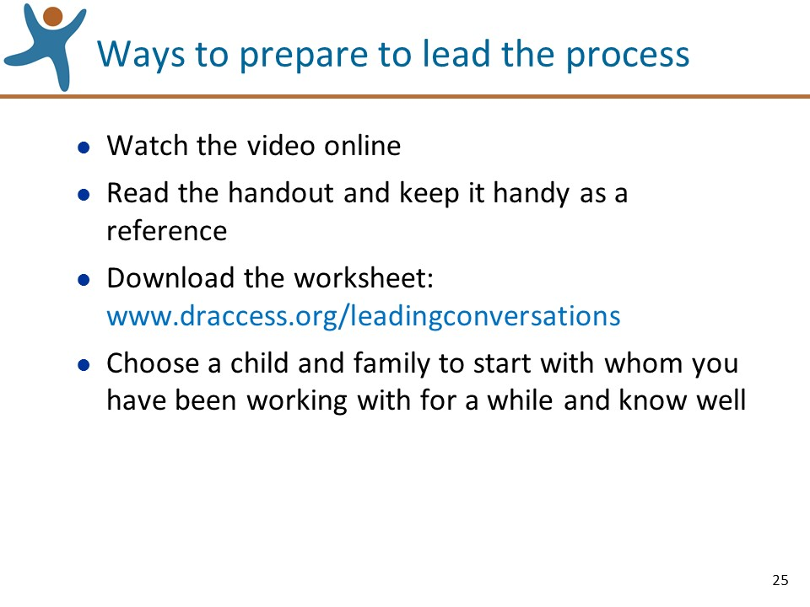 | Slide 25. Review the information on this slide and make these points:  - On this slide are a few things you can do to prepare to lead this process.
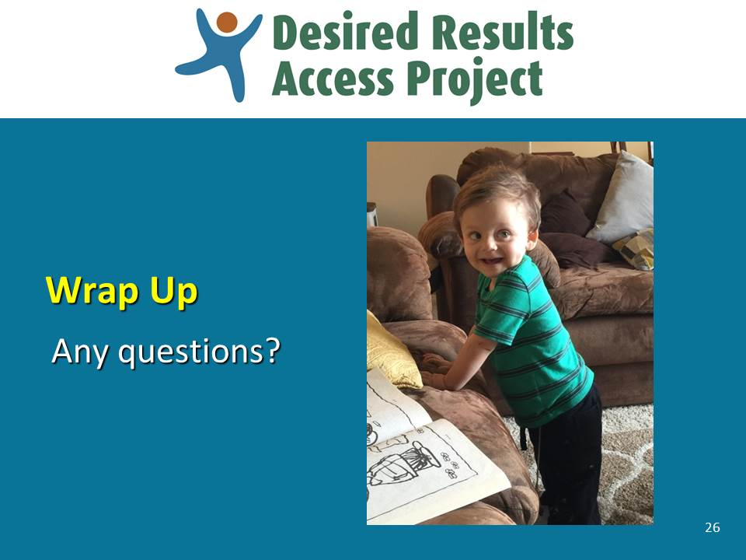 | Slide 26. Review the information on this slide and make these points:  - Lead a discussion: Do you have any last minute questions about the process?

